Stat365 Final Group Project

12/09/2025

By: Alexander Galvan, Yuexi Dai, Dyuthi Ganesh Reddy, Fatima Hashmi, and Zhuoxuan Li

Introduction

This project is designed to apply and adapt the Bayesian-style modeling techniques taught this semester, we set out to estimate data parameters and build regression models using the Wine Quality Dataset:https://www.kaggle.com/datasets/yasserh/wine-quality-dataset/data.
The dataset describes the amount of various chemicals present in wine and their effect on its quality. From this data, there are 12 features: 1-11 describe various physiochemical characteristics of selected Portuguese “Vinho Verde”, including residual sugars, sulfates, and density. The data consists of 1143 observations for said wines, each judged by a sensory score of 1 to 10. For this project, we used Markov Chains (MCMC) and various diagnostics to estimate parameter distributions and explore regression coefficients. Results from our analysis follow:

Results

- Bayesian Estimation

(i). Discrete Data

For the discrete data, we looked at whether a wine is “high-quality” or not. The original quality scores range from 3 to 9, so we turned this into a simple yes or no outcome. A wine was coded as 1 if its quality score was 7 or higher, and 0 if it was below 7. Using this definition, we had N=1143 wines in total, and Y=159 of them were labeled as high-quality. Our goal was to estimate θ, the true proportion of high-quality wines in the dataset.

- Prior Specification: In order to estimate θ, we used a Binomial model of Y~Binomial(N,θ). For θ, we chose Beta(1,1) prior, which is the uniform distribution on the interval 0 to 1. This prior gives all possible values of θ equal weight and does not favor any particular value of θ beforehand. It is also conjugate to the Binomial mode, which means we can calculate and write down the exact posterior.

- Theoretical Posterior (Conjugate): With the Beta(1,1) prior and the data values Y=159 and N=1143, the posterior for θ is: θ| Y~ Beta(1+159, 1+1143-159).
Using this Beta distribution, we calculated the posterior mean, posterior SD, and the 95% credible interval.

- MCMC Estimation (using stan()): Even though the posterior has a closed-form solution, we ran an MCMC sampler in Stan to estimate θ numerically. Our Stan model used the same Binomial likelihood and Beta(1,1) prior. We ran 4 chains and obtained a large number of posterior samples.

- MCMC Diagnostics: To check whether the MCMC worked properly, we examined the trace plot, posterior density plot, and autocorrelation plot. The chains mixed well and did not show drifting or any sort of sticking behavior. Autocorrelation plots: Rapid decay to near-zero, demonstrating low autocorrelation.
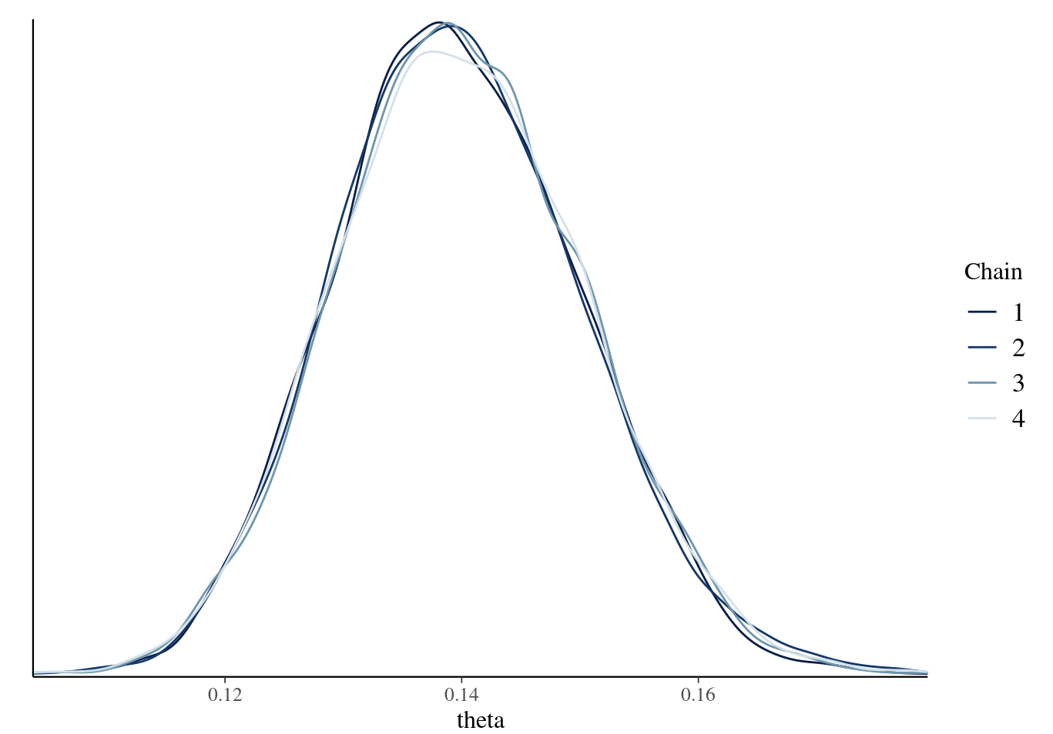
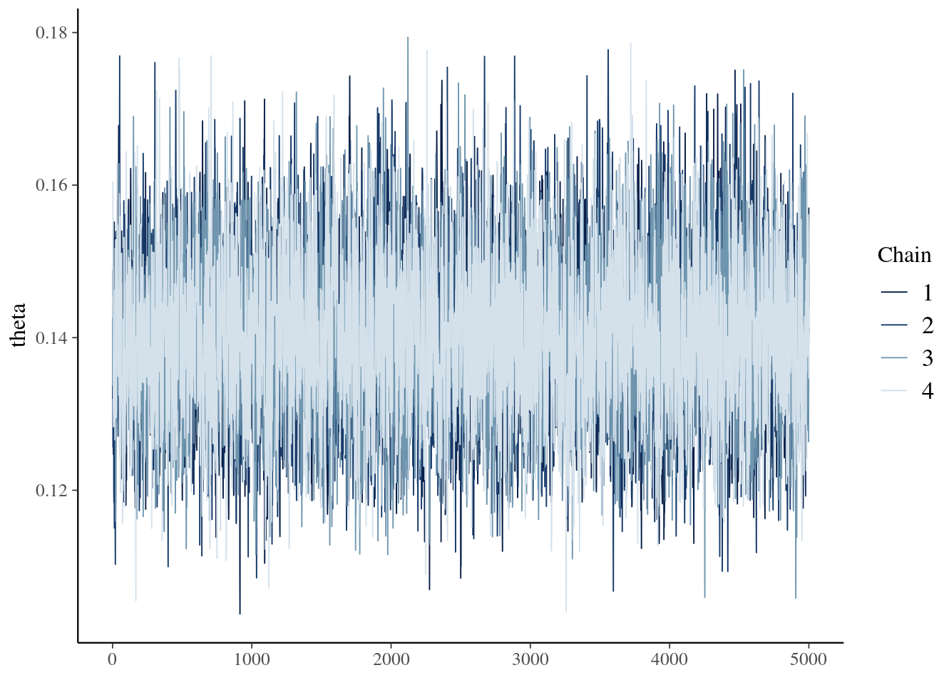
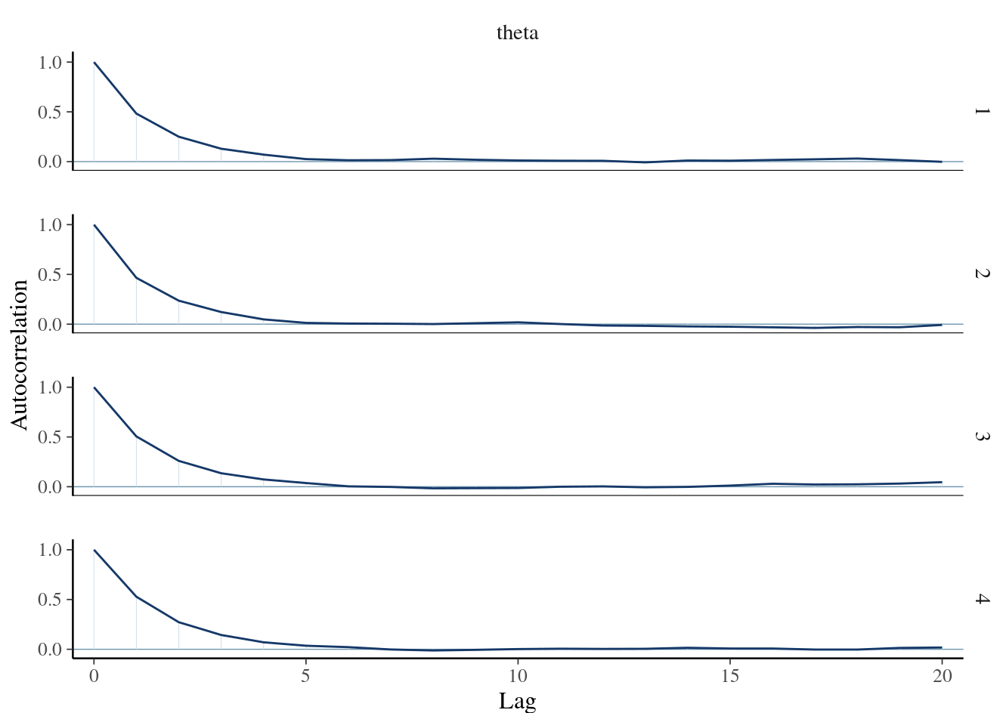
We also conducted the numerical diagnostics:
- R-hat is essentially 1.0006, which indicates good convergence.
- The effective sample size ratio is 0.334, large enough for reliable estimates.

- Comparison MCMC vs. Theoretical Posterior: Finally, we compared the MCMC estimates to the closed-form Beta posterior. The posterior mean, spread, and 95% intervals from MCMC matched the theoretical values extremely closely and well.
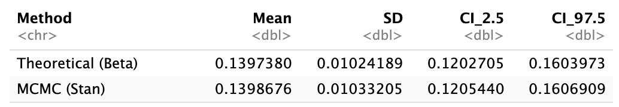
We saw a close alignment between MCMC and theoretical results which validates our MCMC implementation and confirms the accuracy of the sampling algorithm. The Beta-Binomial model has a known analytical solution and since MCMC is reproducing the result. Since the results align so closely, we can be confident that our estimate of θ reflects the information in the data.

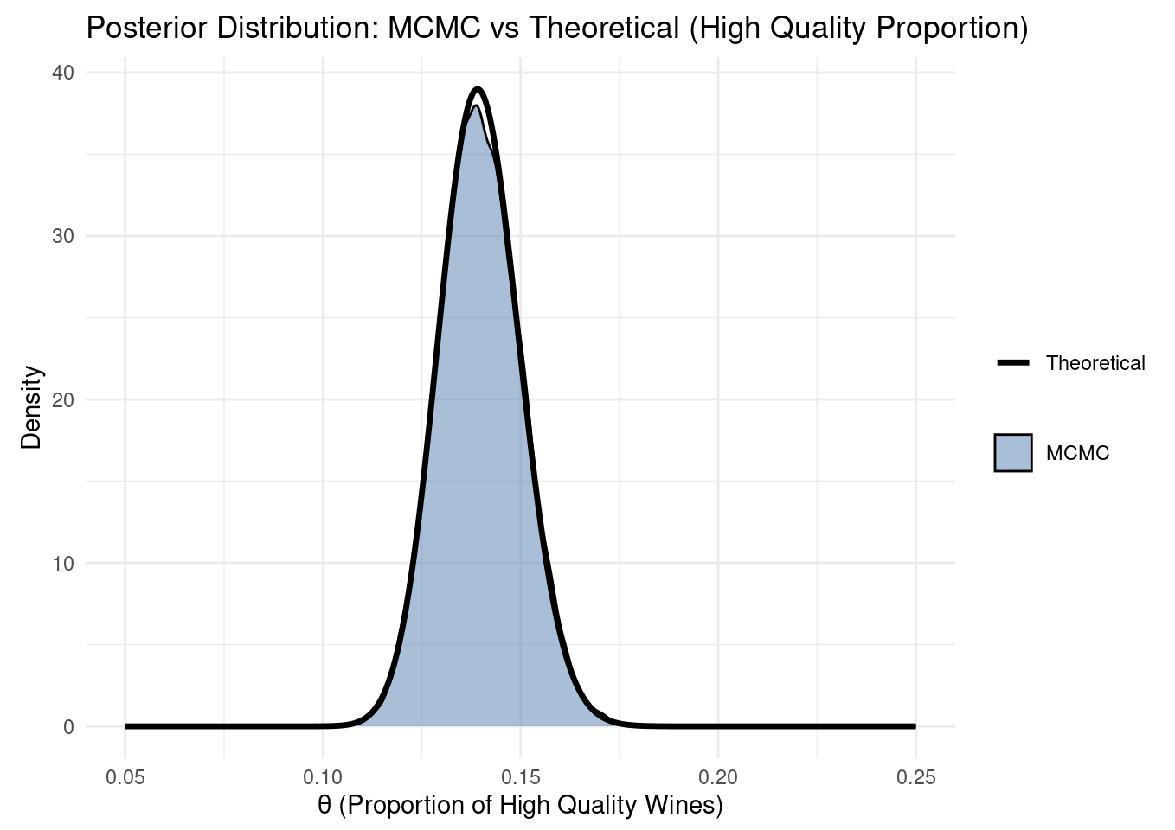

- All in all, we used a binary indicator for high-quality wine (≥7), we estimate θ, which is the proportion of high-quality wines under Beta(1,1) prior, and we had found that the theoretical posterior is Beta(160,985), and confirmed through our MCMC diagnostics (R-hat is about 1, alongside the stable trace & density plots, etc.) that the sample posterior closely matched our theoretical result.

(ii). Continuous Data

For continuous data, we chose “alcohol” as the parameter. We aim to estimate the posterior distribution of alcohol content (μ) in wines, assuming the data is normally distributed. We used stan( ) to perform the MCMC estimation, and compared the results from MCMC estimation to the theoretical one.

- Prior Explanation: We selected μ ~ N(10, 2²) as the prior. A normal prior is conjugate to the normal likelihood, allowing the posterior to remain normal. It’s weakly informative, which ensures that the sample data could dominate the posterior distribution.

- Theoretical Posterior: Our theoretical posterior for the mean alcohol content (μ) is 10.44% with a 95% credible interval of [10.38%, 10.50%]. The posterior standard deviation of 0.032 is a lot smaller than the prior SD of 2.0, demonstrating that the large sample size has reduced our uncertainty about the parameter. Data has effectively dominated the weakly informative prior.

- MCMC Estimation using stan( ): The Stan model specifies a Normal likelihood for the observed alcohol data with known standard deviation(σ = 1.082) and a Normal prior(μ ~ N(10, 2²).

- MCMC Diagnostics: The chains in trace plot mix well with no trends, indicating convergence. In the density plot, ​​all chains have similar distributions, confirming convergence.
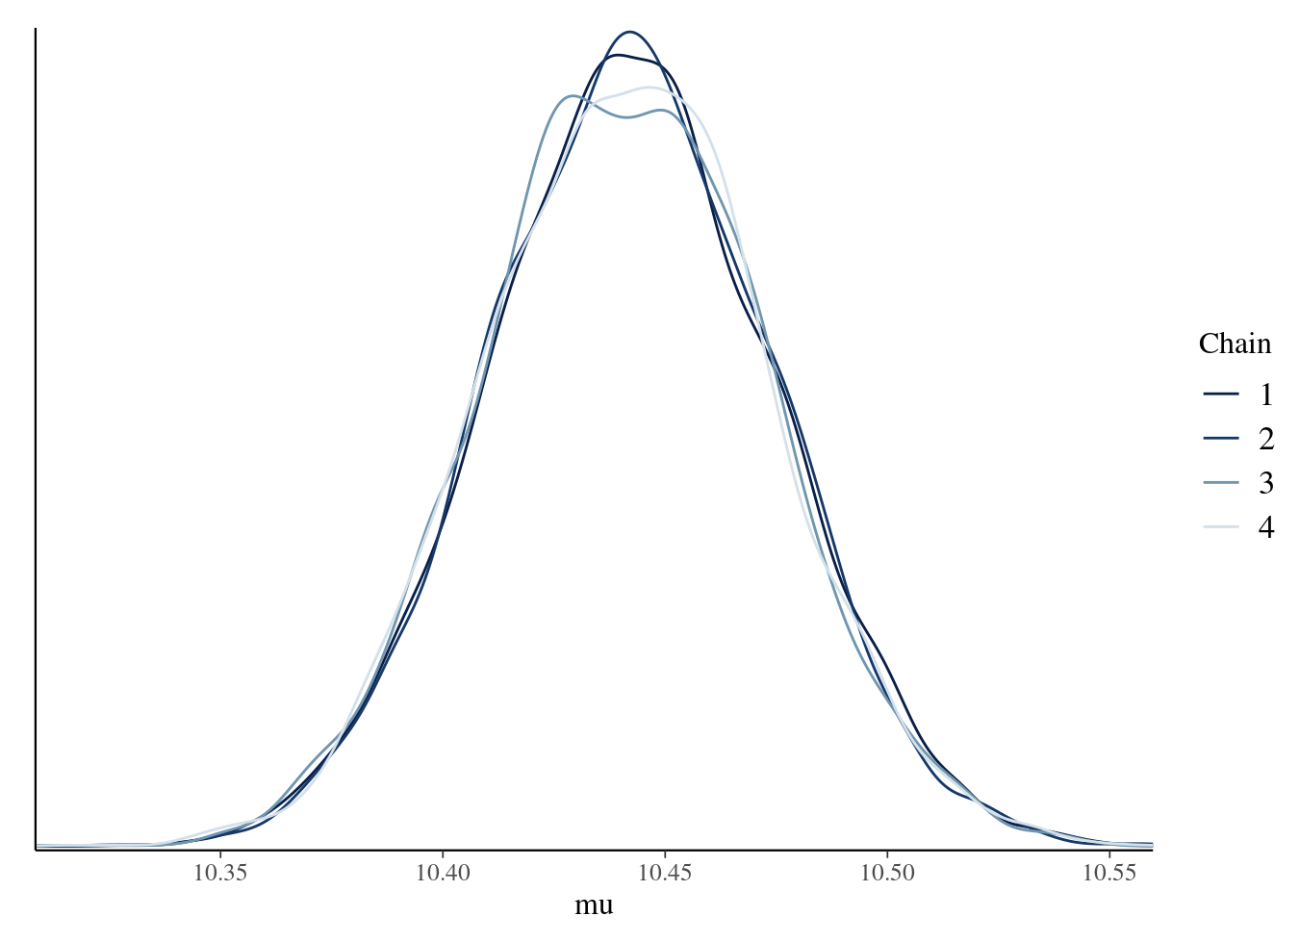
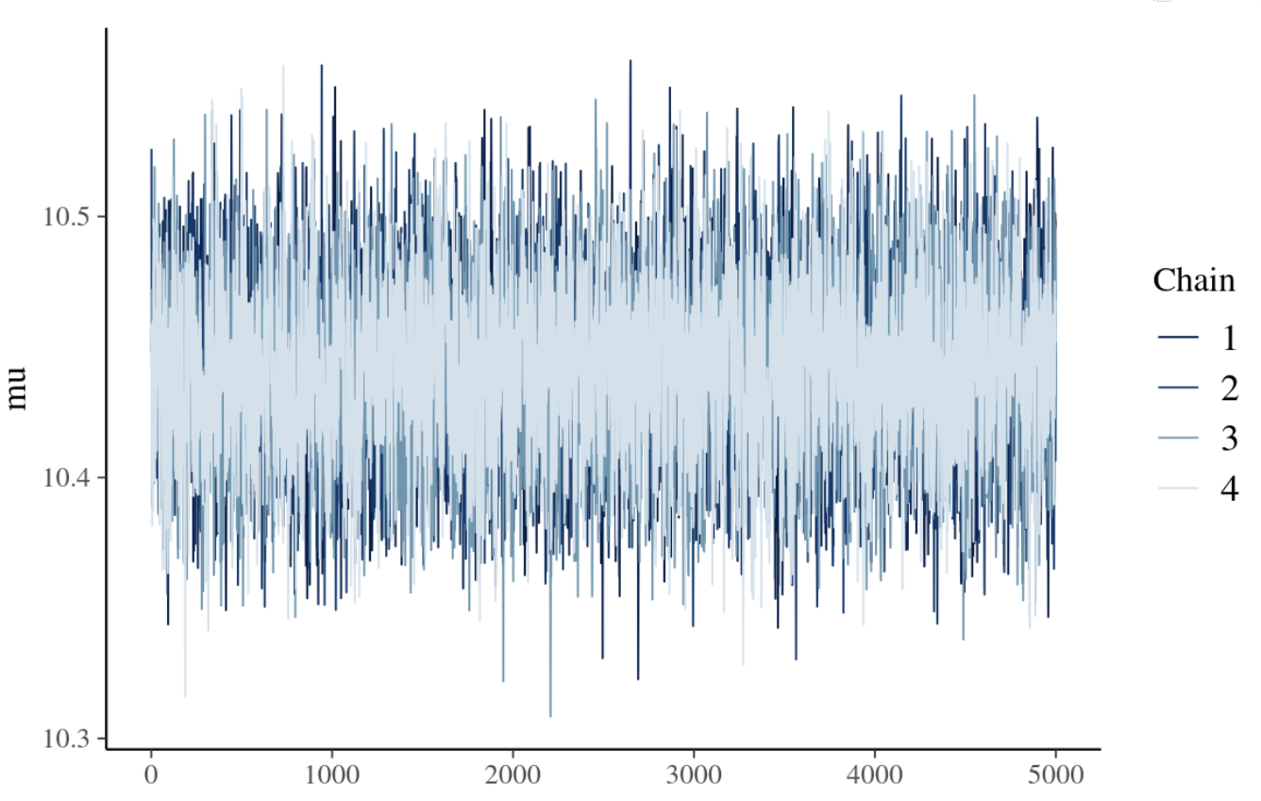
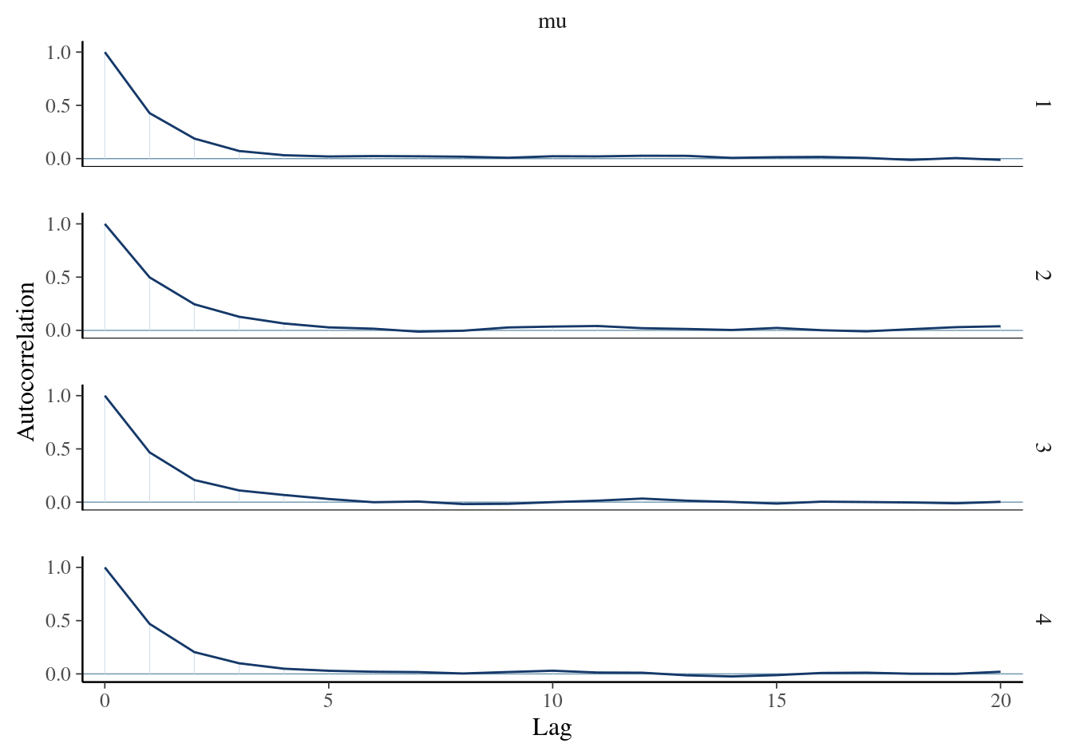
We also conducted the numerical diagnostics:
- R hat is 1.0004 (< 0.1), indicating good convergence.
- Effective sample size ratio is 0.354, which is sufficient for reliable posterior inference.

- Compare MCMC with the Theoretical Posterior:
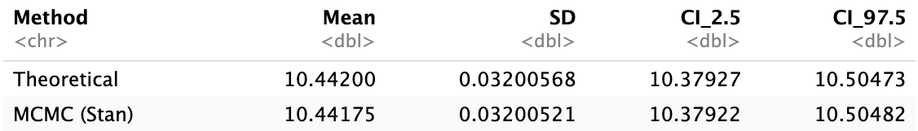
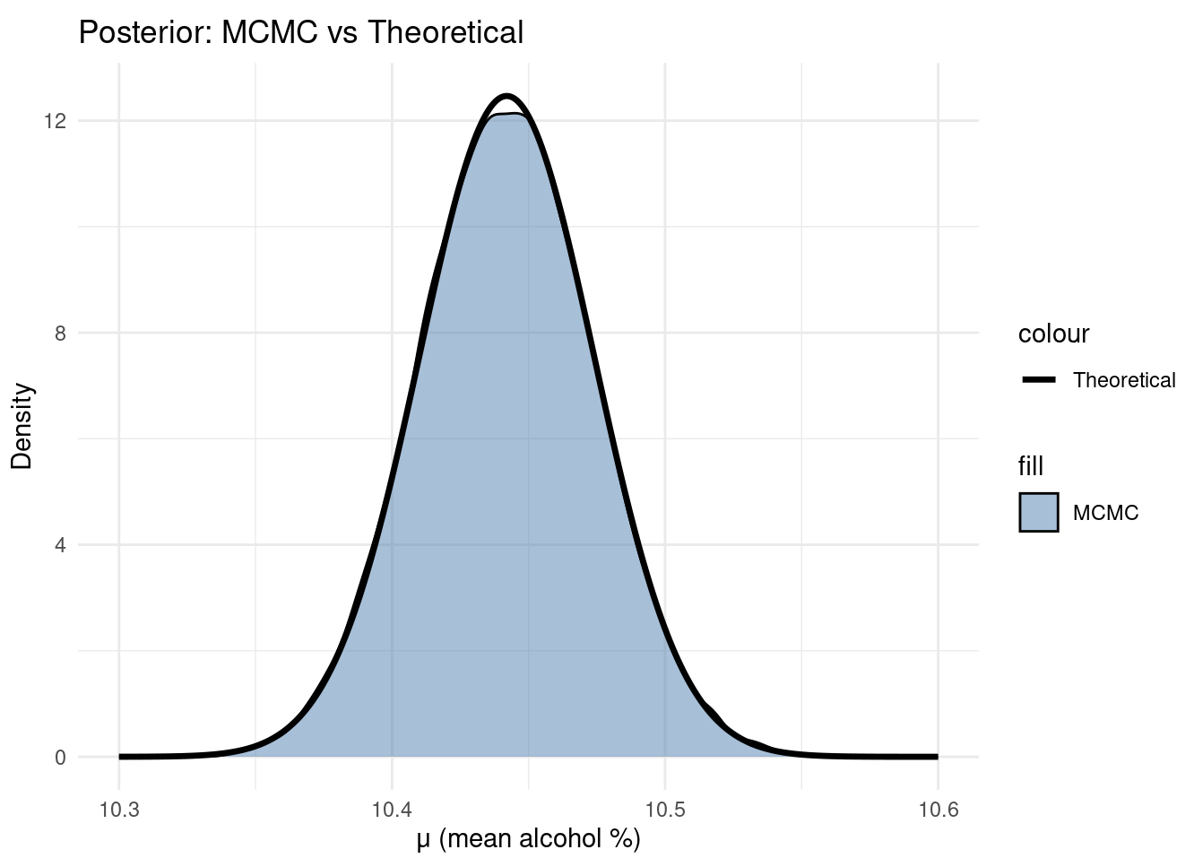
Graphical representation:
The close alignment between MCMC and theoretical posterior validates our MCMC estimation and confirms the accuracy of the sampling algorithm. This comparison is possible because the Normal-Normal conjugate model has a closed-form posterior solution.

- Bayesian Regression

To begin our regression using MCMC, we’ll consider two models to determine which regressors best predict wine quality scores. The first will be a full model that includes all 11 predictors (excluding the intercept), and, based on the regression results, we’ll create a reduced model that includes only the most impactful predictors. Next, we’ll specify weak priors for the intercept, coefficients, and variance. These assumptions will typically be weakly informative, so to allow the data to “speak for itself,” since the posterior distribution is proportional to the combination of the prior and the data. But to get a more accurate analysis, we’ll also use the Autoscale option in our stanarm glm function to set the coefficient and variance priors closer to what is observed in the data. These adjustments can be seen below:

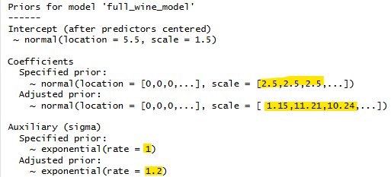

Not forgetting the intercept, we’ll use a summary of the response variable to find a centered estimate to provide for the glm function’s internals, which it uses to output uncentered estimates for the posterior. Since the mean is 5.66 and the max and min are 3 and 8, we’ll model our intercept with a normal distribution at a location of 5.5 and a standard deviation of 1.5. We’ll use a normal distribution to model our predictor coefficients and an exponential distribution for the variance, given its log-normal characteristics and positive-only distribution. But before examining the posterior distribution, we’ll view how weak our prior assumptions are by using prediction density plots for the response, and fitted line plots for two predictors (volatile acidity and alcohol content):
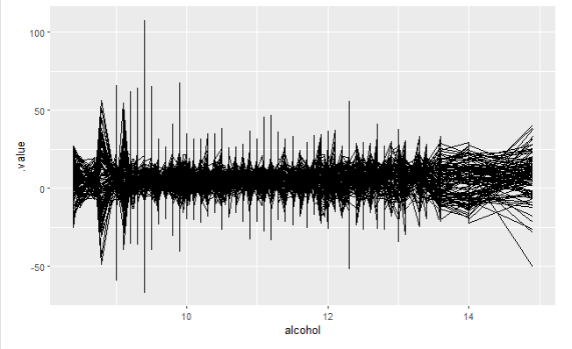
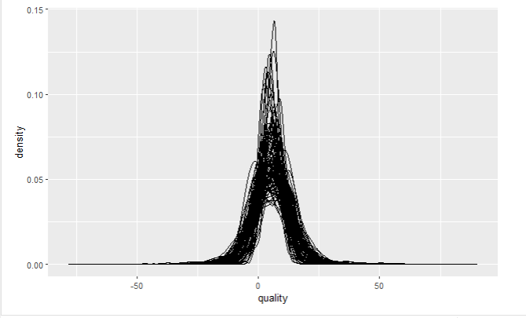

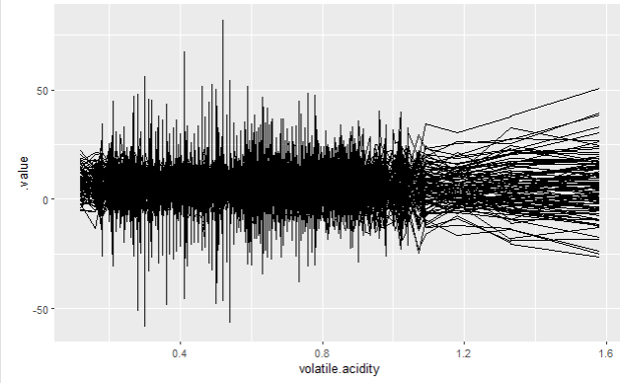

With weakly informative priors, we observed that one hundred prediction draws for quality were loosely and normally centered at 5.5, and that the alcohol and volatile acidity coefficients were fitted with draws centered near 0, with variance from -25 to 25. Putting it all together, given the parameters previously discussed and Y observations normally modeled by mu and sigma, where mu is a linear combination of said parameters, we have the full regression model as:
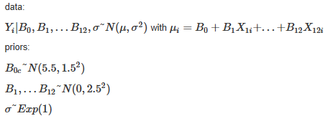
So with priors set, we can now run our MCMC and examine the various trace plots, chain densities, and autocorrelation diagnostics to ensure our Markov chains ran well:
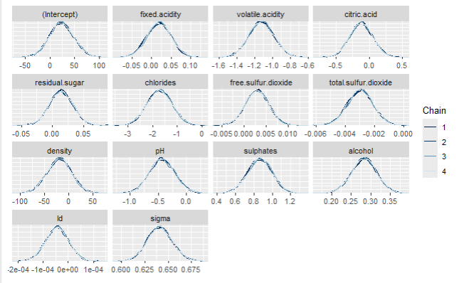
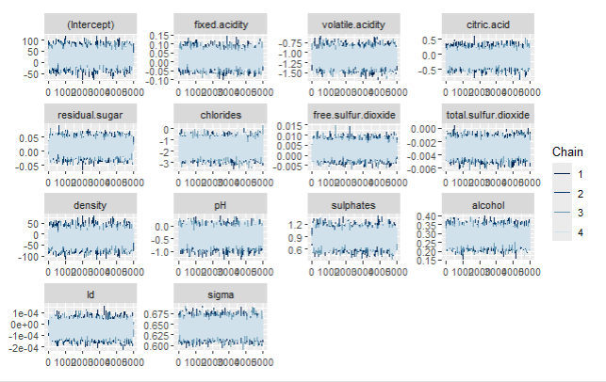
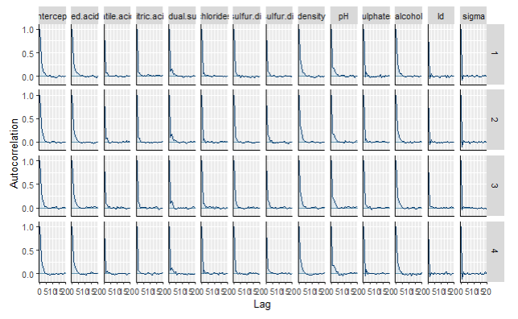
While slightly overwhelming given the number of predictors, we find that our chains mixed well across proposal values, exhibited low autocorrelation, and have generally aligned densities. These are good signs that our MCMC toured well without issue. Continuing, we examined a summary of the analysis to view the Rhat and effective sample values. As seen, the Rhat values of 1 show chain variance stability for between and within chains, and the effective sample sizes show effective ratios between 0.4 and 1.1 (n_eff / 20000) for the coefficients, sigma, and intercept, indicating efficient sampling from our MCMC and low correlation between samples:

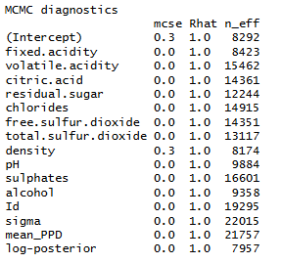

With trustworthy MCMC results, we then look to our estimates to trim what is seemingly insignificant:

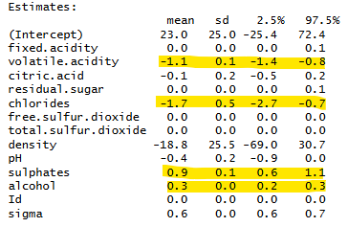

As highlighted above, only volatile acidity, chlorides, sulphates, and alcohol have, given the data and priors, 95% credible intervals outside of 0. In other words, these variables had significant effect on the response, based on our simulation results. Now, using these predictors as the basis for the reduced model, we can see the MCMC results below:

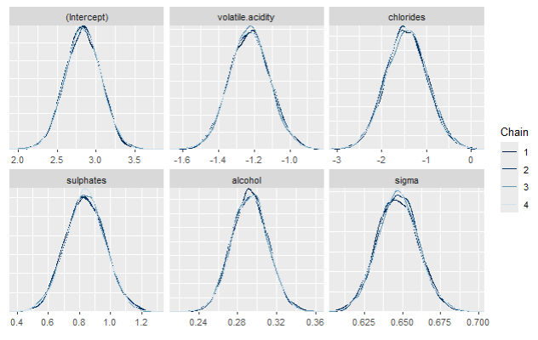
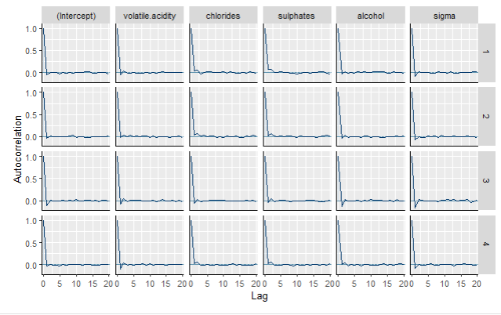
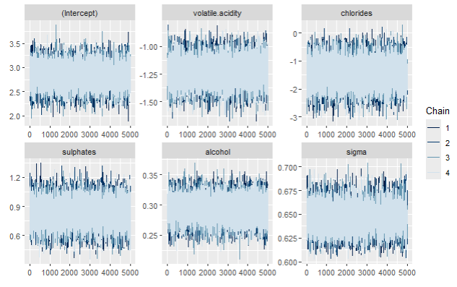
With fewer predictors, it's we have an easier time seeing that our reduced model’s MCMC chains mixed just as quickly and efficiently as our full model, also showing low autocorrelation and convergence to the same densities. Rhat and effective sample size diagnostics also reflect similar estimates to our full model:

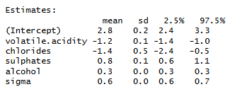
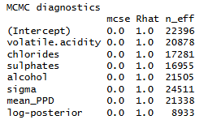
:
Now with both models, we can sample some of the 20,000 parameters estimated and compare their fits to the actual quality scores by using pp_check():

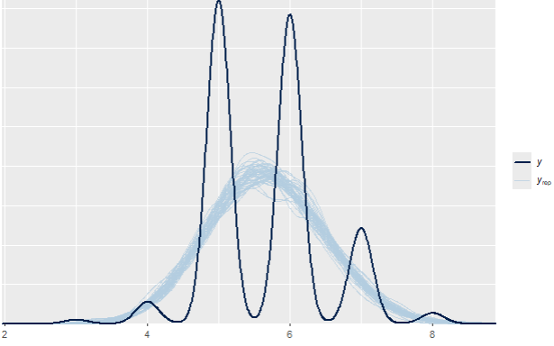
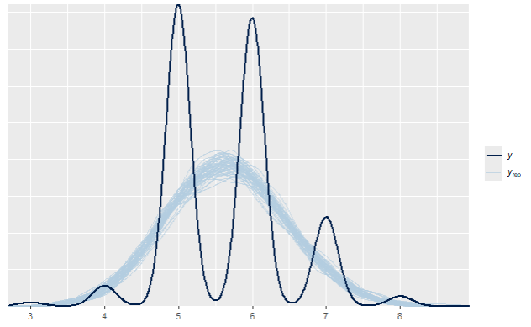
Immediately, we see some troubling alignment issues, where our fits from the estimated parameters from both models (full on the left, reduced on the right) both don’t perfectly match the distribution of actual quality scores from the data. While this may be cause for concern, we might remember that the quality scores were compiled from discrete values ranging from 1 to 10, with some examiners subjectively evaluating wines. So it makes sense here that the observed data exhibits concentration for whole numbers. And while it's faint, the subjective sensory scores do exhibit Gaussian patterns: higher densities in the center, weaker yet equal densities in the tails. Moving on to predictions with our models, we use rstanarm’s posterior_predict() to get predictions, and overlay posterior prediction intervals on the data using ppc_intervals():

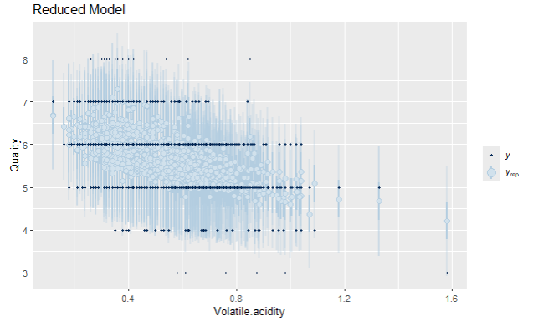
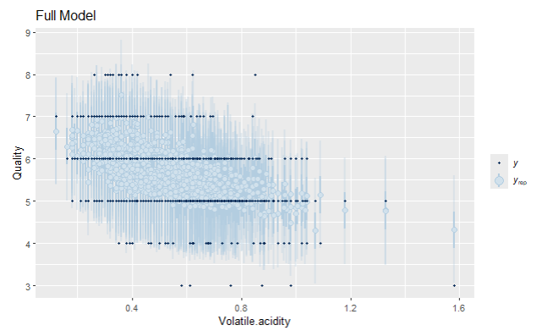

From the PP intervals, we can see that both models have decent coverage of the observed data. This is reinforced by the 10-fold cross-validation results seen below:

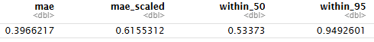
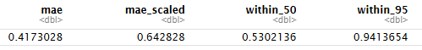

With the MAE (median absolute error) between predicted quality and actual being small at about 0.4 for both models, 0.62 for scaled errors, and roughly 0.53 for 50% PPIs and 0.94 for 95% PPIs in both models, we can say that prediction coverage is good in both our reduced and full models with minor errors. But to definitively compare their predictive powers, we can calculate each’s ELPD (Expected Log-Predictive Densities) to determine which is better:

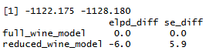

Using loo() and compare_loo(), we find that the full model may have 6 units of better predictive power, with the true difference being roughly within 11.8 units or 2 SE of the estimated difference. But with this small, possibly 0, difference in predictive power, we can determine that the smaller model is better due to parsimony, or the least complicated. And while useful in comparing models, the details of ELPD are complicated and out of scope for this report.

Moving on to the final section, we simulated a set of predictions based on some fixed values in our reduced model’s predictors. Setting volatile acidity to 0.7, chlorides to 0.076, sulphates to 0.56, and alcohol to 9.4, we can predict a distribution of quality values that would capture the possible results of these fixed values:

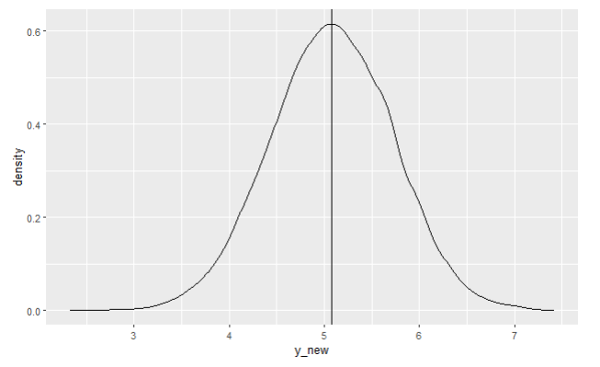
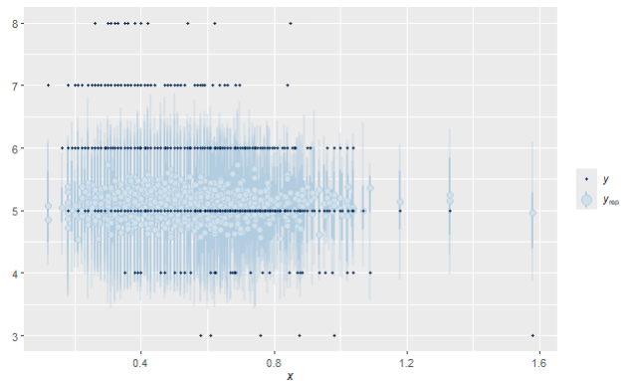
As seen above in the density and PPI plots, the distribution of these new values closely aligns to 5, which was the actual value observed in the data set for those fixed values. Summarised, below, we find the error of our fixed predicted to be small on average, meaning that our model performs well under these fixed settings:

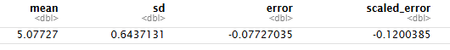

Conclusions

Using Bayesian-style thinking and MCMC techniques, we were able to estimate data parameters and build regression models using functionality found in the rstan and rstanarm packages. We did this by setting weak priors and specifying our model for discrete estimation using beta-binomial conjugates, normal-normal conjugates for the continuous estimate, and intercept, coefficient, and variance predictors for the regression models. We were able to check MCMC diagnostics for each section and determine whether our chains behaved well using trace, density, and autocorrelation plots, along with Rhat and effective sample size. Our results conclude that MCMC is an effective tool for Bayesian-style thinking and investigation.

Citations

Johnson, A. A., Ott, M. Q., & Dogucu, M. (2022). Bayes Rules!: An Introduction to Applied Bayesian Modeling. Chapman and Hall/CRC. //www.bayesrulesbook.com/

Cortez, P., Cerdeira, A., Almeida, F., Matos, T., & Reis, J. (2009). Wine Quality [Data set]. UCI Machine Learning Repository. https://archive.ics.uci.edu/dataset/186/wine+quality. https://www.kaggle.com/datasets/yasserh/wine-quality-dataset/data

Goodrich B, Gabry J, Ali I & Brilleman S. (2024). rstanarm: Bayesian applied
regression modeling via Stan. R package version 2.32.1
https://mc-stan.org/rstanarm.

Gabry J, Mahr T (2025). “bayesplot: Plotting for Bayesian Models.” R package
version 1.14.0, <https://mc-stan.org/bayesplot/>.

